

**Grandma Attacked Outside Store In Roslindale**

One dead, two injured in Mattapan shooting

**METRO SPORTS BUSINESS & TECH OPINION**

WELCOME, JOHN

**TODAY'S PAPER**

**Summer Fitness Challenge Starts Monday**

Sign up now

**By Jerome Campbell and Emily Sweeney** Globe Staff, Updated August 14, 2018, 4:50 p.m.

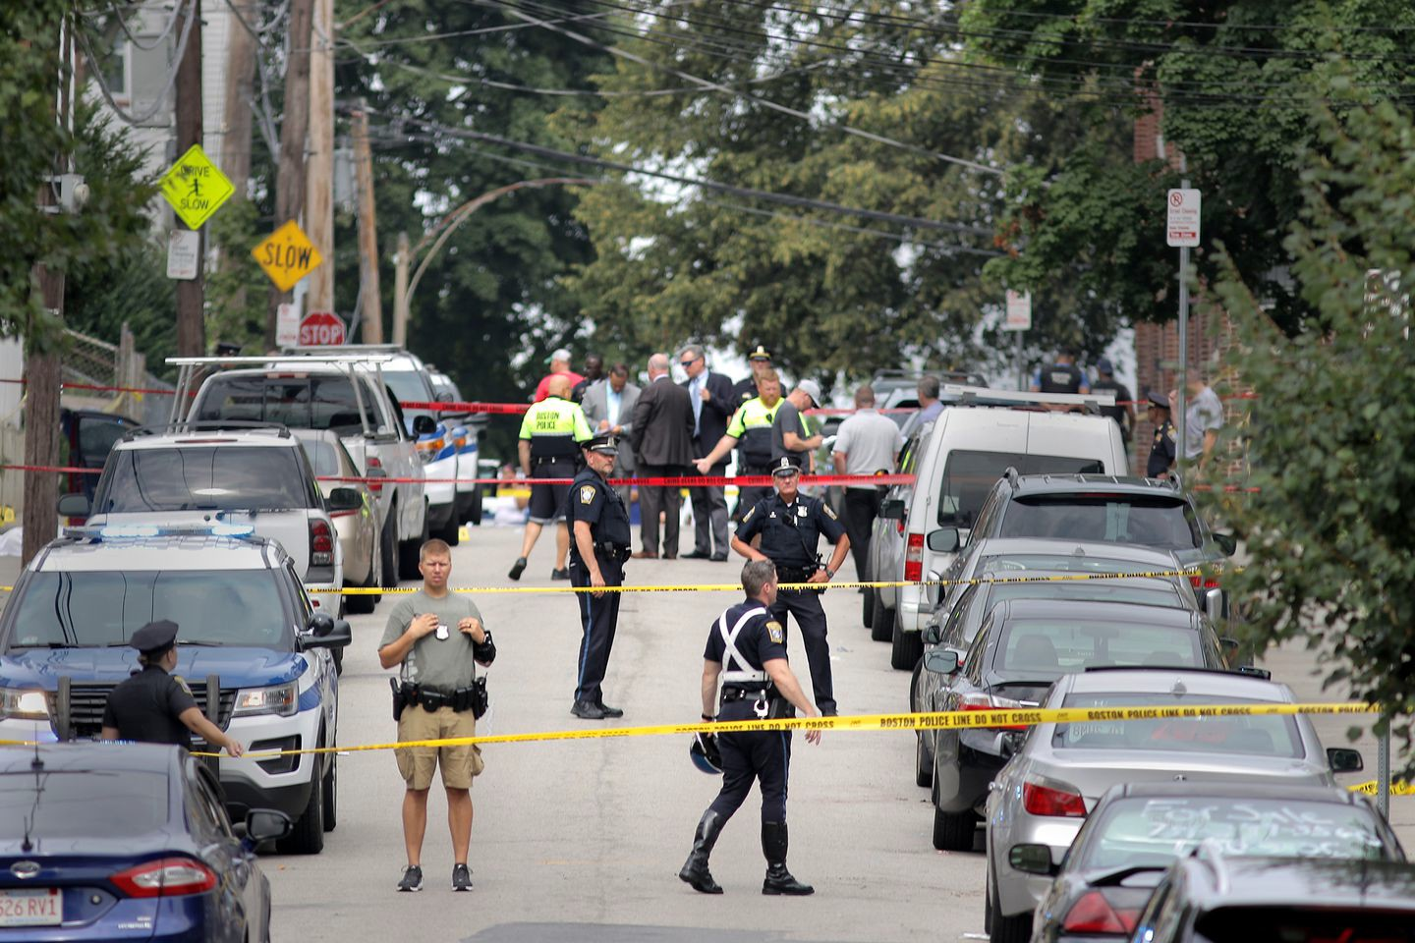

Three men in their late 20s were shot on Deering Road near Blue Hill Avenue in Mattapan on Tuesday. LANE TURNER/GLOBE STAFF

One person was killed and two others were wounded in a broad-daylight shooting in Mattapan Tuesday morning, Boston police said.

The shooting took place around 9:48 a.m. on Deering Road near the intersection with Wellington Hill Street. One person was later pronounced dead, police said. The two other victims suffered injuries that were not believed to be life-threatening.

Boston Police Commissioner William G. Gross spoke to reporters at the scene Tuesday, saying all three victims were men in their late 20s. Gross said at one point the three victims were in a motor vehicle.

“At this time, it doesn’t appear to be random,” Gross said. “We’re asking for everybody’s help on this, as we usually do. So if there are any witnesses, every bit of information is important.”

Advertisement

By about 1 p.m., the street lined with triple-deckers had been reopened, and cleanup crews were pressure-washing blood from the sidewalk. Shocked and bewildered residents were still gathered on porches in the neighborhood, talking in hushed tones about the incident.

**Get Today's Headlines in your inbox** Enter Email

[example@email.com](mailto:example@email.com)

**Sign Up**

The day's top stories delivered every morning.

“There were so many people who were on the porch when the police came, but people just say they know nothing,” said neighbor Jose Lopes, 54, as his hands trembled. “They’re not protecting anyone by being quiet. The rest of us still live here.”

Gross said the department is working hard to stop gun violence and asked that the public do its part by cooperating with police investigations.

“Folks, the cold hard fact is: There’s too many guns on the street,” he said.

Gross said Boston police have removed 400 guns from the street this year. He also said there were 131 nonfatal shootings by this time last year, and this year there have been 91.

“We’re down 40 shootings,” he said. “But stats are stats. One homicide and one shooting is too many.”

Advertisement

Harold Meyers, who lives across the street from the scene, said he heard at least five shots at the time of the shooting but stayed inside.

“I knew not to move,” said Meyers, 67, who was familiar with the sound of gunfire from his childhood in Trinidad. “I waited about 10 minutes, then looked outside, and the police had already arrived.”

Meyers said most neighbors keep to themselves, but more vigilance might have prevented the shooting.

“People say minding your business will keep you out of trouble, but it seems to have still found us,” Meyers said. “If we just looked out for each other more, maybe we could have avoided this.”

Gross noted that police recently made an arrest in connection with the homicide that occurred at 34 Claybourne St. in Dorchester on June 5.

“It does work when people come forward and help us out,” he said. “We just hope we can continue that trend, so we can knock these senseless acts of violence down.”

Gross urged anyone with information about the Deering Road triple shooting to contact the homicide unit at 617-343-4470 or by sending a text to 1-800-494-TIPS.

John R. Ellement of the Globe staff contributed to this report. Jerome Campbell can be reached at [jerome.campbell@globe.com . Follow him on Twitter @JeromeRCampbell.Emily Sweeney can be](mailto:jerome.campbell@globe.com.FollowhimonTwitter@JeromeRCampbell.EmilySweeneycanbe) [reached at esweeney@globe.com. Follow her on Twitter @emilysweeney.](mailto:reachedatesweeney@globe.com.FollowheronTwitter@emilysweeney)

# BOSTON GLOBE VIDEO

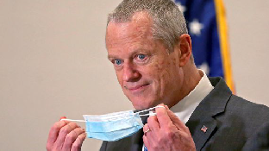

2:23

Baker announces ‘VaxMillions’ lottery program SHARE

Governor Charlie Baker announced residents who are fully vaccinated against COVID-19 will have the chance to win $1 million in a special Lottery sweepstakes. (Photo by Matt Stone/Boston Herald via AP)

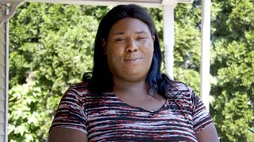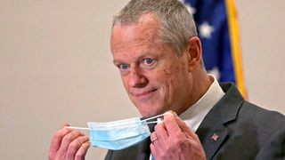

**Baker announces ‘VaxMillions’ lottery program**

**NOW PLAYING**

**Moose spotted on Route 3 in Chelmsford**

**What Black liberation means to me: Athena Vaughn**

# SEE MORE VIDEOS

**MOST POPULAR ON BOSTONGLOBE.COM**

1. Life sciences is poised to be Boston’s dominant industry. Has the area become the Silicon Valley of biotech?
2. Some lawmakers want to ban critical race theory in schools. So, what is it?
3. String of attacks on men is keeping Waltham on edge
4. Why women are finally starting to get construction jobs in Mass.
5. Two sisters, one house, and a mystery
6. ‘My Name Is Bulger’: Two brothers, one documentary, an only-in-Boston story
7. Tom Brady’s roots run deep into 19th-century Boston
8. Is there something wrong with the air in South Portland, Maine?
9. The downside of ditching masks: the return of colds, flu
10. How Massachusetts communities are celebrating the state’s first official Juneteenth



**VIEWS FROM OUR COLUMNISTS**

**YVONNE ABRAHAM**

Energy efficiency is a low-hanging fruit to combat climate change. So why can’t everyone get access to it?

**KEVIN CULLEN**

Bill Bratton on American policing and the challenge facing the Boston Police Department

**THOMAS FARRAGHER**

A salute across the ages to an old squad leader

**SHIRLEY LEUNG**

A working mother’s manifesto: Pandemic provides a once-in-a-generation chance to course correct how we work

**JENEÉ OSTERHELDT**

The pride I carry with me: Karim

**ADRIAN WALKER**

‘The best Boston movie no one’s ever seen’: ‘Blue Hill Avenue’ at 20

**MORE ON GLOBE.COM**

**PROVIDED BY: PHILIP MORRIS INTERNATIONAL**

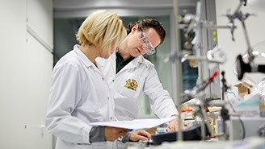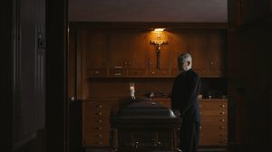

**Is a future without cigarettes within reach?**

This company has a team of more than 400 scientists and R&D experts working on smoke-free alternatives.

**THE GREAT DIVIDE**

**Some lawmakers want to ban critical race theory in schools. So, what is it?**

As national debate over race-related curriculums rages on, here is a lesson on the subject and the controversy surrounding it.

**INNOVATION ECONOMY**

**Life sciences is poised to be Boston’s dominant industry. Has the area become the Silicon Valley of biotech?**

Since December, you can find six major indications that Boston is the undisputed center of the life sciences industry, a place where ideas and products that change — and save — people’s lives around the world originate.

**‘My Name Is Bulger’: Two brothers, one documentary, an only-in- Boston story**

The Discovery+ film offers an unusually intimate view of Whitey and Bill Bulger.

**GLOBE MAGAZINE**

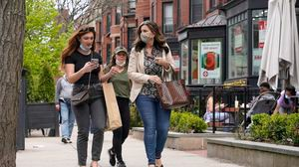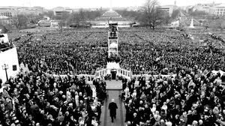

**Is there something wrong with the air in South Portland, Maine?**

Residents have lived near more than 100 massive petroleum storage tanks for decades, never really knowing if they’re breathing in dangerous chemicals. Now they’re fighting to find out.

**The downside of ditching masks: the return of colds, flu**

Since the state’s mask mandate was lifted, face coverings have started to come off — and stay off. But according to infectious diseases doctors, the return of facial freedom might come with some downsides, like a resurgence in cases of the common cold and the flu.

**The state’s second-biggest health insurer has a buzzy new name**

Tufts Health Plan and Harvard Pilgrim Health Care merged in January but didn't name the new company they created until Wednesday: Point32Health.

**A treasure map for an American tyrant**

Donald Trump exposed weaknesses that a would-be dictator could exploit to end our democracy. It’s now up to lawmakers, voters, and public officials to prevent that from happening.

**Coolidge Corner Theatre unveils plans for major expansion**

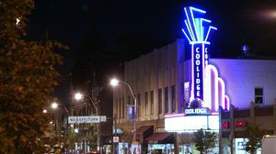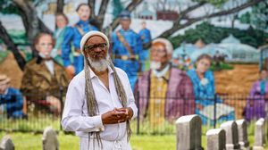

Brookline officials are reviewing a proposed expansion of the landmark Art Deco cinema that will add two new screens — and over 200 seats — as well as a larger lobby and third-floor community space, with a catering kitchen and outdoor roof deck.

**How Massachusetts communities are celebrating the state’s first official Juneteenth**

For more than a century, Juneteenth was a Texan holiday, then a Southern holiday, commemorating the anniversary of June 19, 1865, when General Gordon Granger of the Union Army told formerly enslaved people in Galveston they were free. Now it will be celebrated for the first time across the Commonwealth as an official state holiday.

**MOST READ IN THIS SECTION**

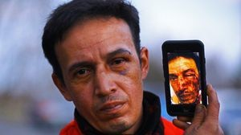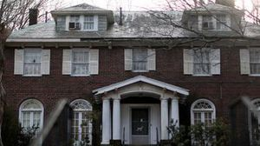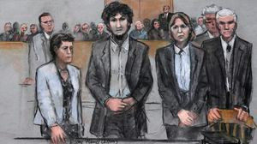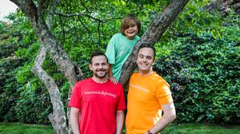

**THE GREAT DIVIDE**

**Some lawmakers want to ban critical race theory in schools. So, what is it?**

**String of attacks on men is keeping Waltham on edge**

**Two sisters, one house, and a mystery**

**GLOBE MAGAZINE**

**Is there something wrong with the air in South Portland, Maine?**

**The downside of ditching masks: the return of colds, flu**

**How Massachusetts communities are celebrating the state’s first official Juneteenth**

**Death penalty should be reinstated for Tsarnaev in Boston Marathon bombings case, Biden administration tells Supreme Court**

**A Milton gay couple was harassed anonymously for years. Then a piece of handwriting unraveled the mystery**

**FOLLOW US**

**SUBSCRIBE NOW MY ACCOUNT CONTACT MORE**

Digital Access / Home Delivery / Gift Subscriptions

Log In /

Manage My Account / Customer Service

Help & FAQs / Globe Newsroom / Advertise

Newsletters / View The EPaper /

Order Back Issues / News In Education / Search The Archives / Privacy Policy / Terms Of Service / Terms Of Purchase / Work At Boston Globe Media /

Do Not Sell My Personal Information

©2021 Boston Globe Media Partners, LLC